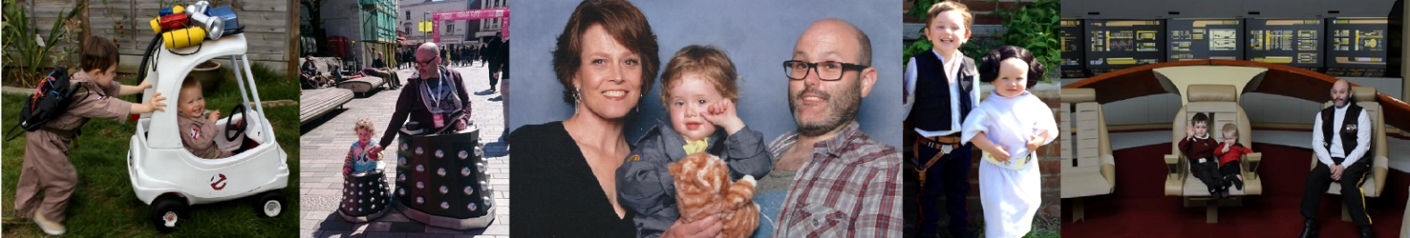
PAUL JONES: THE NERDFATHER

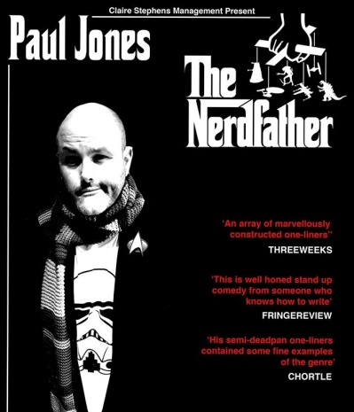

EVENT: Clapham Fringe

VENUE: The Bread & Roses Theatre, 68 Clapham Manor Street
Clapham SW4 6DZ, London

DATE: 23rd October 2016

TIME: 9PM (10PM)

FEE: £8/£6con

They say never meet your heroes…. They’re right, you should make your KIDS meet them!

Join Brighton Comedy Festival Squawker Award finalist, BBC Radio sketch writer and multi-award winning costume maker Paul Jones as he brings his geeks guide to parenting to Clapham Fringe.

Come and see Paul as he combines his trademark killer one-liners, with the heartwarming story of how his lifelong obsession with science fiction helped him deal with fatherhood. This truly is a unique multimedia comedy show that - boldly goes, where no DAD his gone before….

ABOUT PAUL JONES

As a stand up, Paul reaching the semi-finals of ‘So you Think You’re Funny’ ‘BBC Radio New Comedy Awards’ and the finals of ‘Brighton Comedy Festival Squawker Awards’

As a writer Paul has contributed to Radio 4’s ‘That Mitchell and Webb Sound’ and ‘The Odd Half Hour’ and Radio 2’s ‘Parson and Naylor’s Pullout Section’.

“An array of marvellously constructed one-liners.” THREEWEEKS

‘Well honed stand up comedy from someone who knows how to write’ Fringe Review

“His semi-deadpan one-liners contained some fine examples of the genre.” Steve Bennett CHORTLE

For further information or images please contact:

pauljonescomedy@gmail.com Agent: Claire Stephens Management www.pauljonescomedy.co.uk

