A EUROPEAN COLLECTIVE PERFORM AN ADAPTATION OF IBSEN’S A DOLL’S HOUSE AT THE BREAD AND ROSES THEATRE

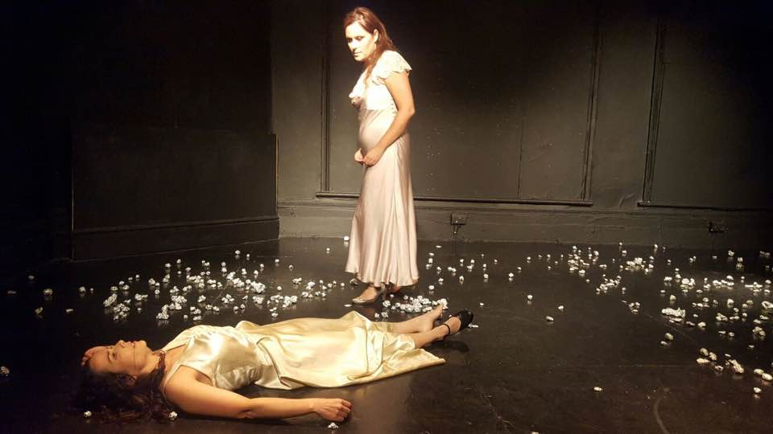

Adapted from Henrik Ibsen’s A Doll’s House, Nora is a co-production by SEARA – Companhia de Teatro de Beja (Portugal) and AREAμ[MI] Compagnia Teatrale (Italy). Two actresses play the same character in order to find themselves. By reflecting on social alienation and identity, the performance confronts the audience with their own fears and past memories. Who am I when I am not with you?

Sometimes, we need to lose ourselves to find our way. After leaving her husband and children, Nora tries to discover who she is without them. Confronted with her past, memories of what she has left behind, she struggles with her decision. She doesn't know who and where she is anymore. "None of this is real." Is it?

Performing for the first time as part of the Clapham Fringe at The Bread and Roses Theatre, this European collaboration is an exploration into one of modern theatre’s most complex female character. Nora is mother, wife, woman, human, citizen with whom we can learn to become the best version of ourselves.

Directed by: David Silva, Award Winner Director at the International Theatre Festival FATAL 2008, Award Winner Playwright with the play "Pinocchio & Red Riding Hood", published in 2005 and, Assistant Director of João Mota (who worked with Peter Brook) at National Theatre D.Maria II in Lisbon.

Show taking place at The Bread and Roses Theatre
68 Clapham Manor Street, Clapham SW4 6DZ, London

Dates Time Ticket prices
Sat 5 Nov 2016 7:00pm £9.50
Sund 6 Nov 2016 7:00pm £9.50

Book tickets via www.claphamfringe.com

Press contact: Marine Begault Telephone: 079 669 415 49 E-mail: yourlittleskylark@gmail.com
Twitter: @nora_doll2016 Facebook: Nora Video Teaser:

