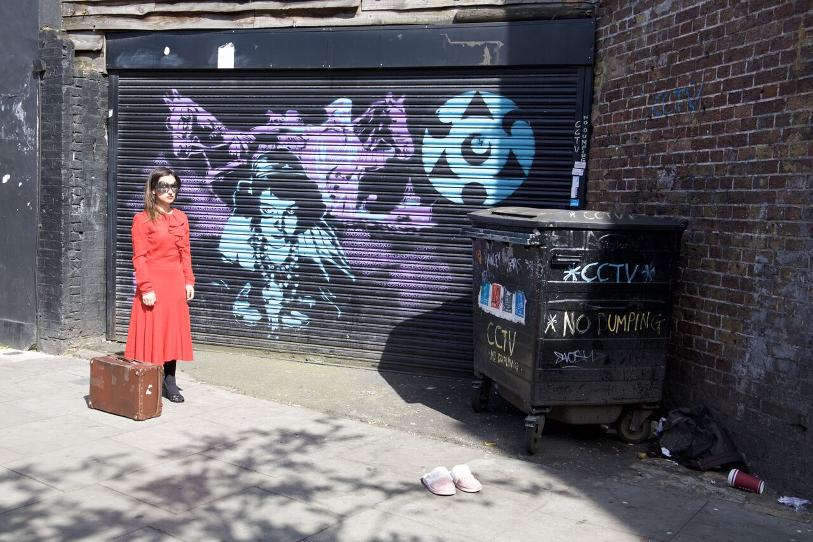
– PRESS RELEASE –

Performing for the first time as part of the Clapham Fringe at The Bread and Roses Theatre, this European collaboration it is co-production by Rastilho Associação Cultural (Portugal) and Bacalao Performance Company (UK, Norway)

A door, a bridge, an individual.
Each can connect or separate space, place, time and people. Bringing together a cast from Canada, England, France, Greece, Ireland, Italy, Scotland, Spain, Russia and Portugal, this devised ensemble piece reflects on otherness as interdependence.
The performers switched memories, reshuffled personal stories, gradually blurring the line between individual memories, merging each image into a common, kaleidoscopic vision of ourselves. In a moment in which bridges are abruptly being closed and islands are moving further away, 'I am because you are' invites the public to question identity building based on the fear of difference. This performance is where we see our future, a safe place in which collective memory is a land to build upon.
Directed by: David Silva, Award Winner Director at the International Theatre Festival FATAL with Othello by William Shakespeare, performed at National Theatre D. Maria II (Lisbon, Portugal) and Teatro Principal (Galicia, Spain). Award Winner Playwright with the play "Pinocchio & Red Riding Hood. Assistant Director of João Mota (who worked with Peter Brook) at National Theatre D. Maria II (Lisbon, Portugal).
Cast: Anastasiya Zinovieva, Konstantinos Moraitis, Lakeisha Lynch-Stevens, Lakshmi Khabrani, Letizia Binda-Partensky, Lucien Campbell, Maria Carmel Birmingham, Nyke Jackson, Scott Watson, Sílvia Almeida and Stefanie Ritch
Assistant Director: Marine Begault
Executive Producer: Sofia Marques
Designer Technician: Sebastian Money
Film Directors and Photographers: Laura Dorn, Ludovic des Cognets

Show taking place at The Bread and Roses Theatre
68 Clapham Manor Street, Clapham SW4 6DZ, London

Dates Time Ticket prices
Sun 30 Oct 2016 9:00pm £9.50
Mon 31 Oct 2016 9:00pm £9.50

Book tickets via www.claphamfringe.com

